**Scope**

The purchase of this custom GS Mobile transaction is to provide a controlled way to return material issued to a work order back to stock (RTS). It will allow the user to RTS a lot, heat originally issued to the job into the original or new bin. The transaction posted will be an issue material to WO (J55). See “Using Transaction” below for details of process and validations.

**Installation**

1. Load ARC 6380
2. Extract project using System Support > Administration > GS Mobile Custom Trans Imp/Exp
3. Stop and restart wirepoll.exe
4. Grant mobile user access to the new custom transaction (system support > administration > gs mobile users > open)
5. Mobile form validation for job, suffix and sequence is an "M" material operation, quantity is valid.

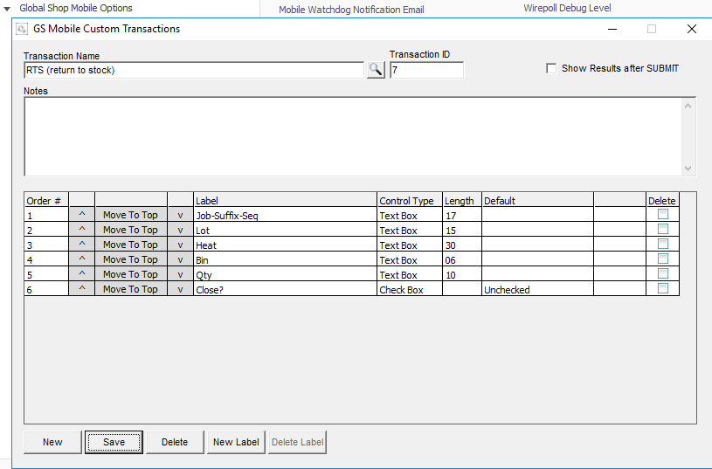

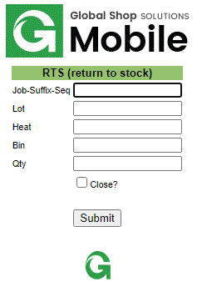

**Using Transaction**

Data Entry

* Job-Suffix-Seq – scan material sequence barcode from material picklist, work order router or issue to wo label.
  + Manually enter, ie 500430 000500
  + Job-suffix-sequence validated
  + Must be a material ‘M’ type sequence
  + Job must not be closed
* Lot – scan lot number
  + Lot number will be validated to item history by job-suffix-sequence
  + Can not RTS more than issued to work order by lot
* Heat – scan heat number
  + Lot number will be validated to item history by job-suffix-sequence
  + Can not RTS more than issued to work order by heat
* Bin – enter bin to RTS into
  + If left blank will use original bin issued to work order from item history
  + lookup item history on lot and heat match
  + Validates bin to bin master
* Qty – enter total quantity to be returned
  + Will support either +/- value
  + Validate for valid number and can’t be 0
* Close? – check the box to close the material seq and open requirements (needed in event the return qty leaves an open balance and seq reopens as the result of the J55 transaction

**Return Results Page**

* Every transaction will be validated with a message stating transaction was successful or failed and reason.

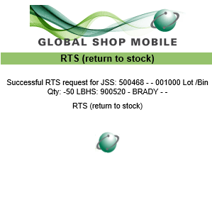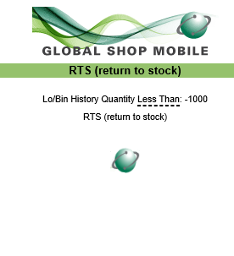

* The transactions that are successful will process through as J55 “issue material to work order”.
* Labels will print if labels are activated for standard mobile issue to wo transaction.
* Document links will be copied from original lot/bin item record issued to job for lot returned to new bin